**Mohammed Mahin Ibnay Mamun (346584)**

**Task 1 unit 10 Assignment**

**Project Deliverables/targets**

**Targets for this application:**

The app will be used to do the following for the AMAP shopping Centre:

* Advertising
* Promotions
* Extraordinary events

It will also be able to show the shops main menu and the layout of the shopping Centre.

The main menus of the stores will display exclusive offers, discounts, and parking.

Overall, the main target is to create an application which works and supports touchscreen for the users Aswell as making it user-friendly with guides for inexperienced users.

* To create a user-friendly user interface
* Create step by step guides for users
* Access to accessibility features such as: zoom tool
* Compatibility of touch screen
* Search bar

**Project Completion Factors:**

**Timescales:**

Timescale simply defines how long it will take to complete a task or an event. Gannt charts are a wonderful way of showing and following this.

The overall timescale for this project is a total of 27 days. This project will begin today on the 02/11/22 and will be complete before the 29/11/22. By the end of this month, the store will be able to use the system without any flaws.

Below is a Gantt chart which I have created to show how I will complete this task withing my given time limit.

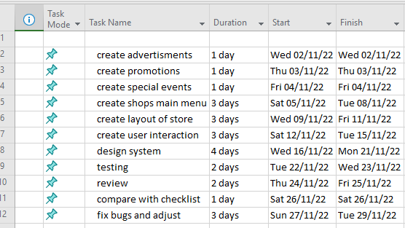

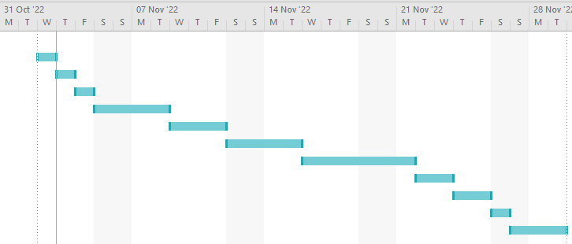

**Application User Interaction**

**Input**:

The specialized digital sign has a touchscreen that may be used to input data into the application. The application will mostly be used using a touchscreen, allowing users to scroll across interfaces, touch buttons and other objects to interact with them, the system will display an interactive keyboard which will be touchscreen and will display what is typed.

customers can also use voice commands to interact with the application. However, this may be harder due to the fact the mall is busy with lots of customers, this would result in unclear interpretation.

**Output:**

When considering output, the main consideration is which font to use. It is best to use black font color on a white background as it stands out well. Making the text bold can help but at times it may be harder to read. Depending on the text displayed, it will decide which font fits will. The most common used fonts are ariel, sans-serif, Calibri and Roboto.

**Purpose of the system**

The purpose of the program is to improve the user's experience in the mall by offering general information, such as the location of a certain store, exits, or amenities like restrooms. The programme also provides information on promotions and unique events that happen within the building.

The user should be able to simply navigate the interface and search for information they require, such as the location of specific items in the centre, while the application should offer the user-desired information they are seeking for.

**Accessibility**

A user-friendly user interface, a variety of input and output methods, and clear information are all necessary for an application to be valuable to its users. People with disabilities should be considered when designing an application to provide maximum accessibility. Common impairments like blindness/visual impairment and hearing loss have an impact on how users interact with computers.

**Task 2 – Designing and Creating**

## **Mood boards**

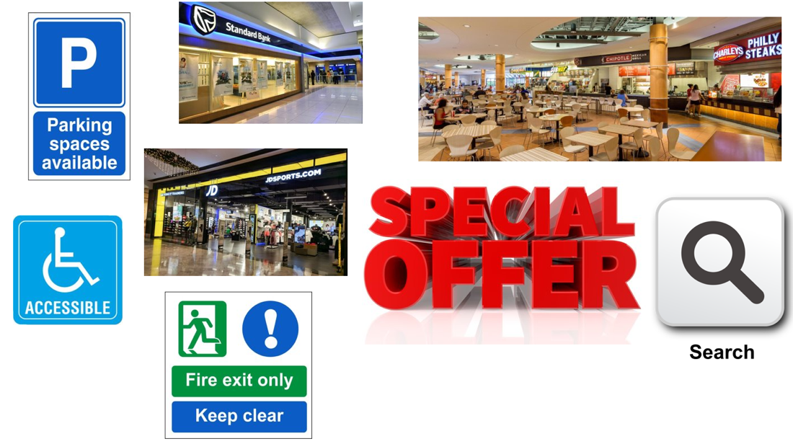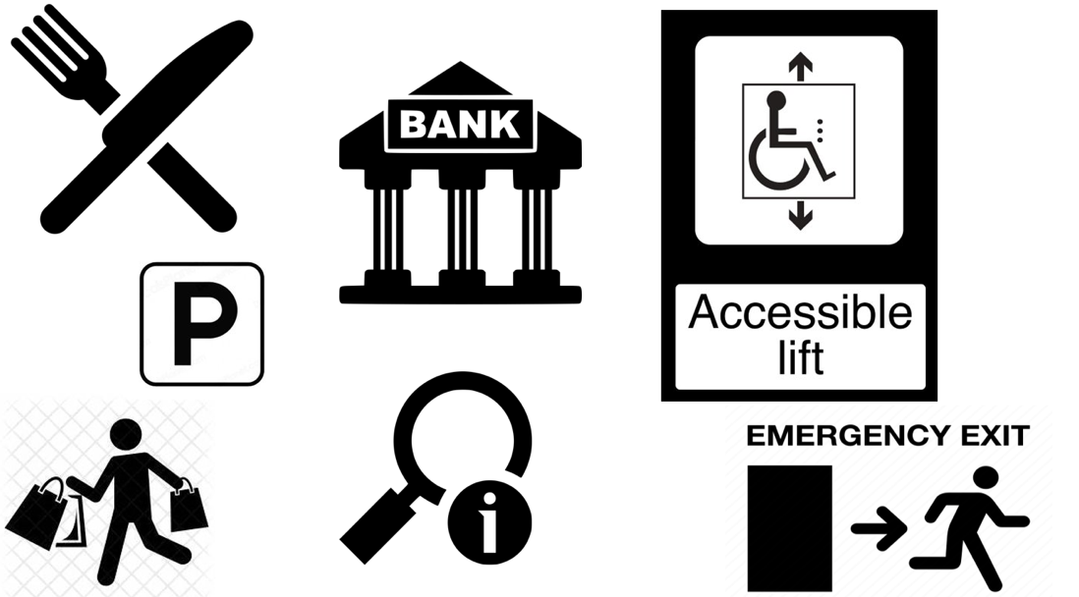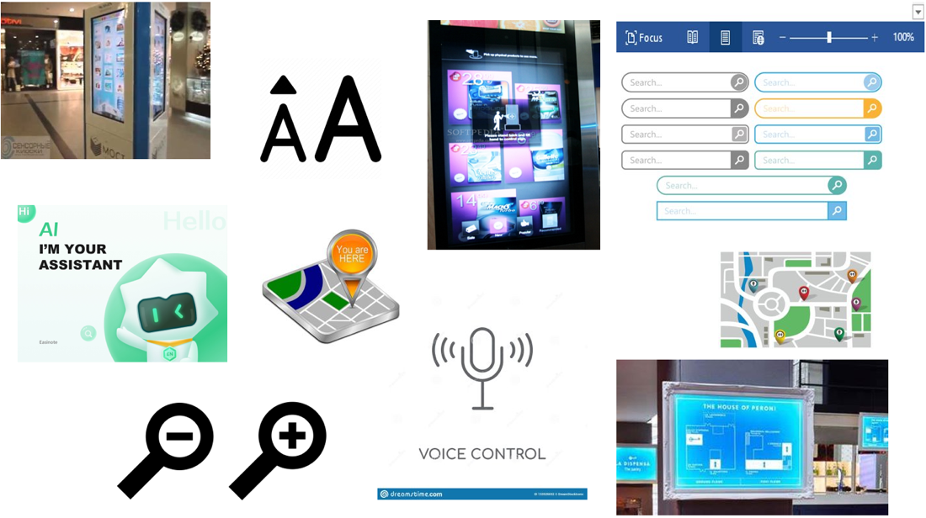

## **Client requirements**

## **Hardware and software requirements**

**Hardware:**

The digital signs company must be contacted to order specialized signs for the application to function in a shopping centre. The following pieces of software and hardware are required for the digital sign.

**Display:**

A screen that displays the application's interface will serve as the application's primary output device. Most of the application's output will come from this screen, which also has a touchscreen as its primary input device. The buttons and interface elements that can be touched will be displayed on the display. Videos, advertisements, and detailed maps of the shopping centre are just a few of the additional items that need to be displayed on the display. The display must be of high quality, have a good color range, be responsive to touch, and have a high resolution.

**Touchscreen:**

Since touch is the application's primary method of interaction, the digital sign must include a touchscreen. The user will need to touch the screen to click or interact with buttons, navigate menus, and screens. This requires that each component of the displayed display be intractable.

**Microphone:**

There must be a microphone on the sign panel's front. This microphone would be used to input the application's voice recognition software, which is used to make the application accessible to people with disabilities like blindness or mobility issues. To ensure clear, understandable audio, the microphone ought to be embedded on the front of the digital sign. Also, the microphone should have built-in noise cancellation to cut out background noise, which can make it hard to hear what the speaker is saying. The sign must have an expensive, high-quality microphone because it must output audio of high quality.

**Connection hardware:**

The app will let you look around the shopping centre for places, events, and discounts and promotions. For this to keep awake to date, the data set for the signs should continually be refreshed. The sign must be connected to the database for this information to be displayed in the kiosk or sign. For the sign to be able to retrieve data from the database that is stored on the shopping centre's servers, it must be connected to the database through both wired and wireless connections.

**Speakers:**

Speakers should be imported to play videos, guides, advertisements, and other media. Because they will be in a noisy public space in a shopping centre, these speakers need to be loud, and they need to be big for both the indoor and outdoor environments. The speaker needs to be clear and have good clarity in addition to being loud. The shopping centre's background noise should be able to clearly be distinguished from the speakers.

**Processing power:**

The digital sign's processing power is not particularly important because the application only requires basic functions from the sign. However, it is still critical that the sign's computer's processing power remain quick and responsive. The justification for this is on the grounds that the application can play recordings and to explore and utilize an intuitive guide of the retail plaza. As a result, the processing power required to play videos smoothly and support this map must be sufficient. Since the processor will also have to deal with user input and interactive elements like buttons and menus, pages and loading effects should be responsive as well.

**Software**

**Operating system:**

Windows ought to be the kiosk's primary operating system. Windows outperforms iOS, Android, and Linux because it is compatible with more third-party software than any other operating system. Windows 10 Pro should be installed on the kiosk because it will be easiest to set up with third-party software like voice recognition software.

**Voice recognition software:**

Because the voice recognition software will provide the application with text for searches and accessibility, the application ought to have embedded voice recognition software built into it. The software will recognize the user's voice by using the sign's built-in microphone to hear what the user is saying. After that, this will be processed into text, which the application will interpret as text for the application's search bars, other fields, or commands.

**Database software:**

The data must be stored in a database to display accurate and up-to-date information about the shopping centre, including parking areas, events, and special occasions. All necessary information about the shopping centre would be stored in this database.

## **Flowcharts**

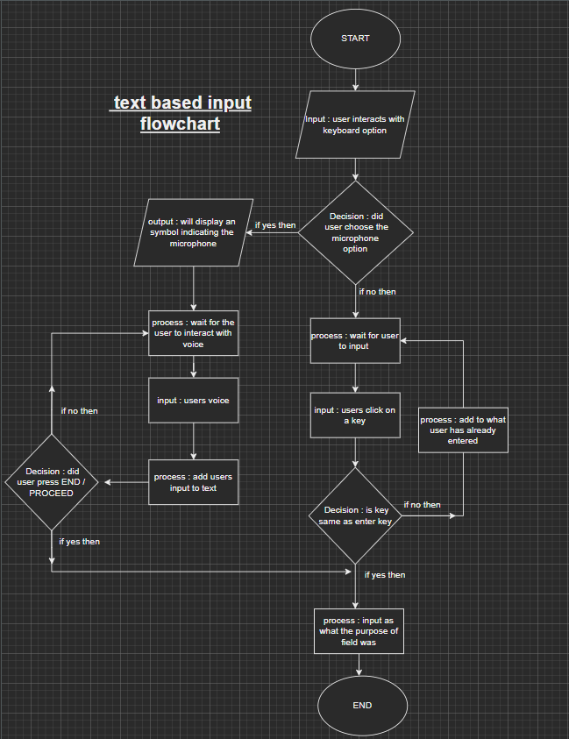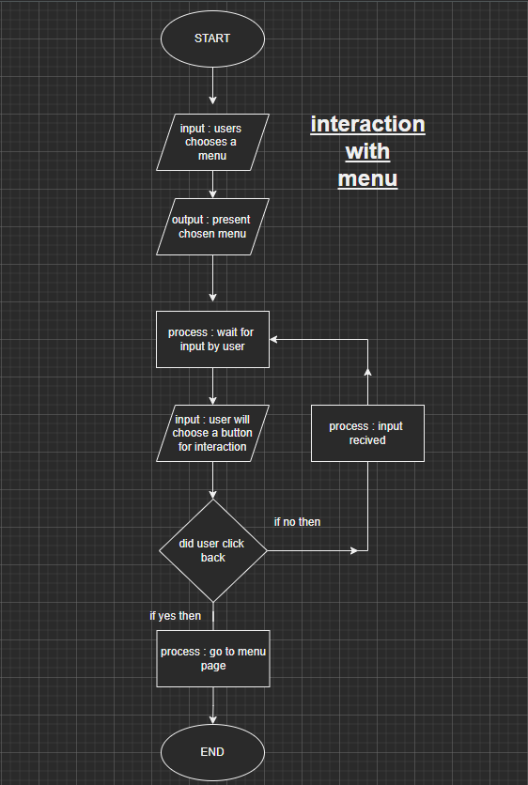

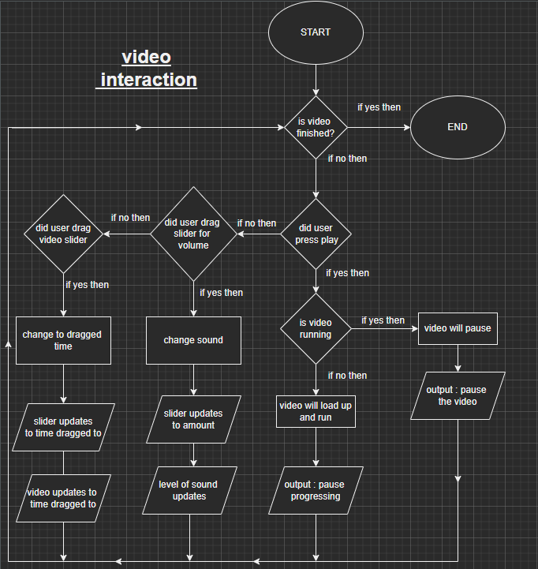

## **Annotated storyboards**

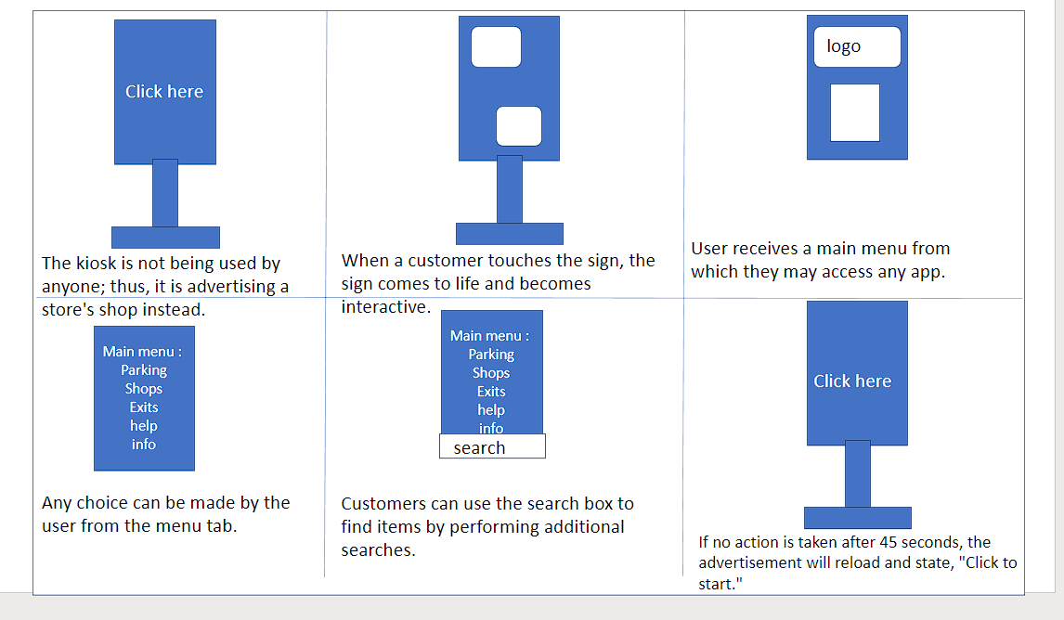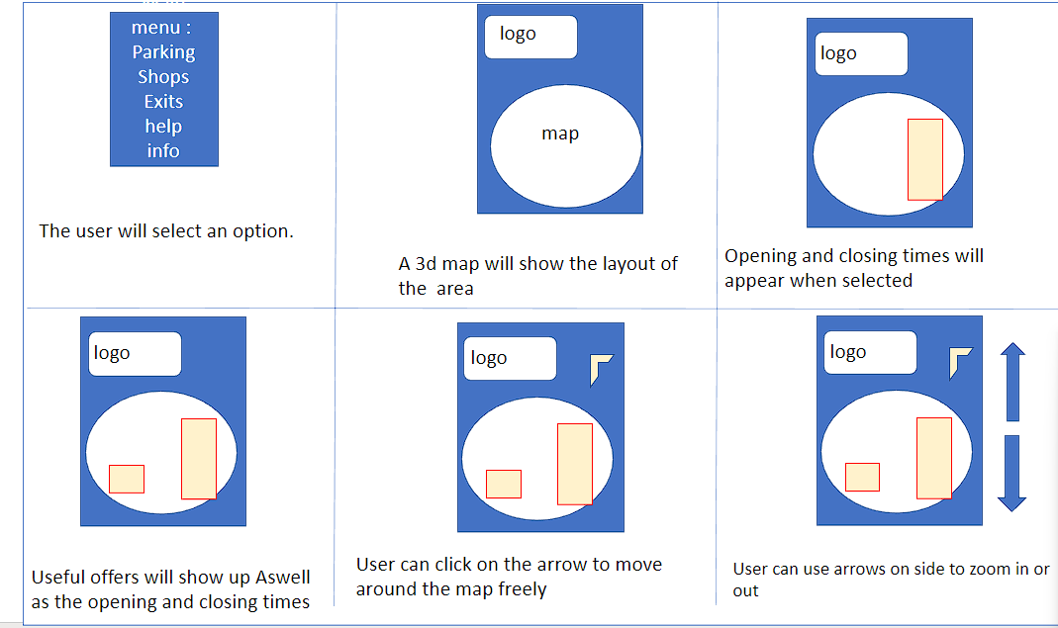

## **Figma Designs**

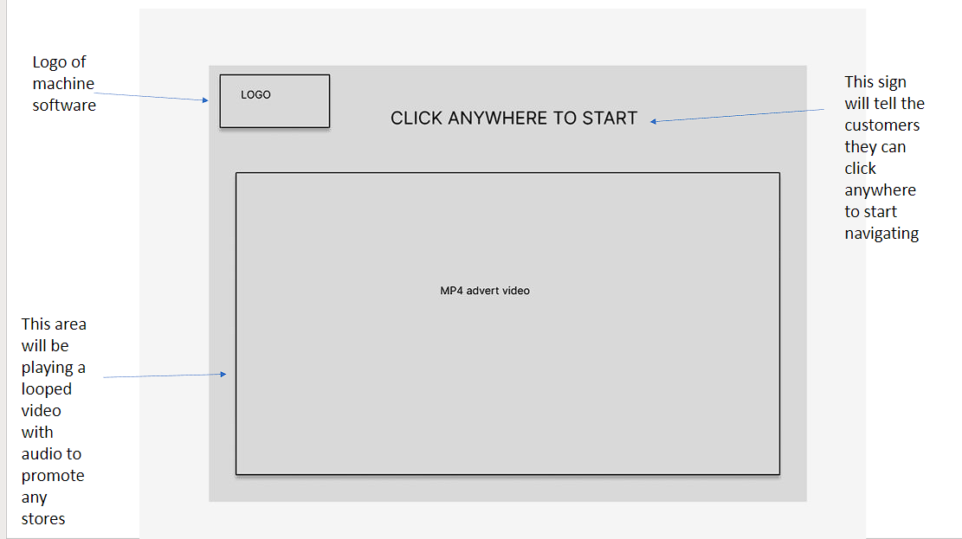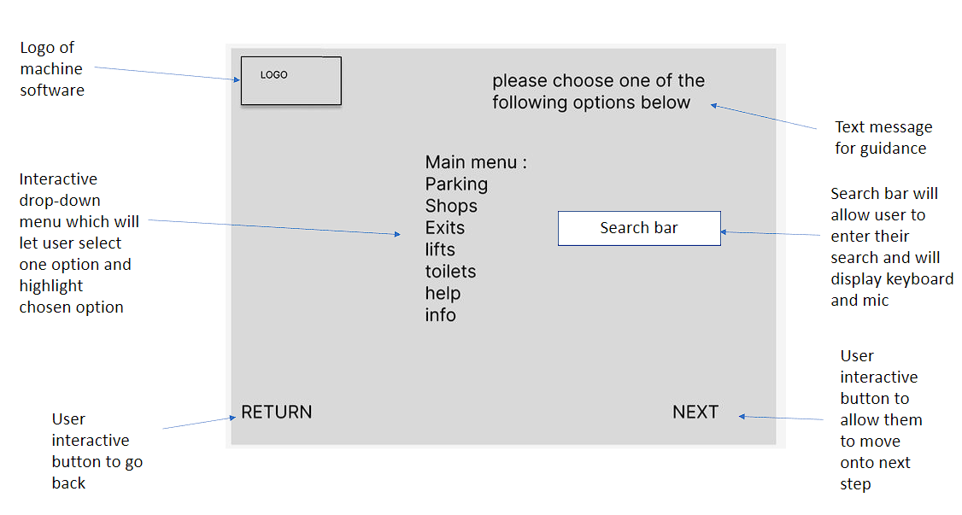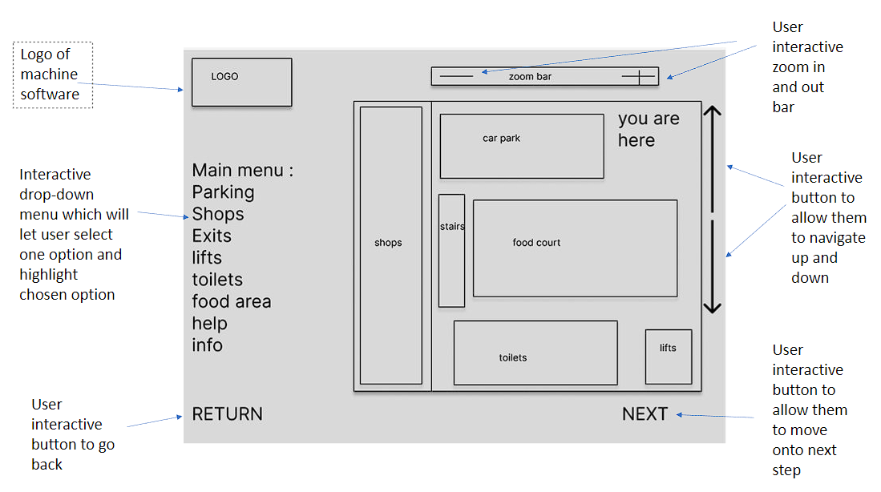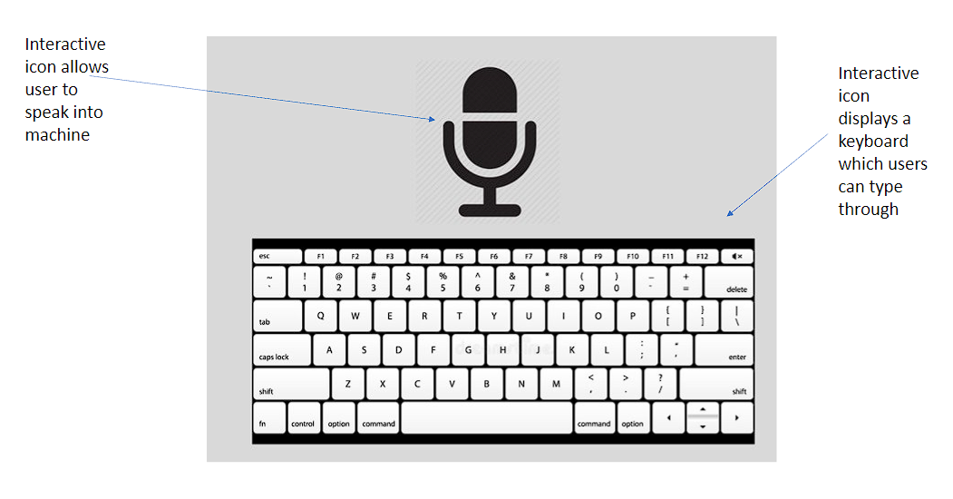

## **Evaluate the advantages and disadvantages of Figma designs**

**Advantages:**

* You can simply discover what you need in Figma because of its straightforward UI interface.
* Figma runs in a browser and on Windows or Mac computers. It provides fantastic fast access features.
* support for a variety of platforms.
* simplicity, compatibility, and adaptability.
* Web-based collaborative design; no installation of an app is required.
* It enables many people to contribute to the design. On a single file, you can invite numerous people and designate any one of them as the admin.

**Disadvantages:**

* When an asset is a component of a complete UI project, default settings frequently make it difficult to locate that asset.
* Undoubtedly, training is required, but it may not be readily available.
* Figma's view settings might be modified to make them simpler for novice users to understand.
* lack of an export option for designs, which may restrict how well you may use the designs you produce in other applications.
* Offline work is not possible. In cases where there is no connectivity, you must keep in mind to store offline files.
* There are occasionally a few usability problems. In Figma, several tools can be difficult to find.
* Figma only has a few shapes, could do with more to make designing better.

**<<Client requirements >>**

* zoom in and out – increase/decrees interface size
* access facilities – large text / languages
* points of interest clearly identified for all - Fire escapes
* current location
* search function interactive keyboard
* audio feedback
* tasks to be performed
* input required – touchscreen and voice
* output required – graphics and audio feedback
* user needs including accessibility considerations, the purpose of the system and environmental.
* mood boards for your layout ideas
* design solution:

1. client requirements
2. hardware and software requirements
3. detailed flowcharts
4. annotated storyboards
5. technical specification for the file formats required bandwidth limitations, target platform
6. technical designs-code
7. consideration of design rules.

**<<HCI rules used and golden rules >>**

**Keystroke** - The keystroke can foretell a user's search strategy for a particular item. Making a model that evaluates how frequently the search bar is used

**Consistency** – The application's logo, a search bar, a return button, and a next button are all present on every page.

**Gestalt law of proximity** – Certain regions are highlighted by the buttons used to interact with the selected options; when the user clicks an option, it is likewise highlighted.

**Back button** – The return button in my model follows Schneiderman's Golden principle of the usage of shortcuts; if the user accidentally clicks the button, they can click next to undo it.

**3d interactive map** – A switchable 3D interface is used for the interactive map. The side move arrow allows the user to navigate the map at their leisure.

**Fitts law** – The application's design takes Fitts' Law into account by keeping all interactive elements near one another. Users only need to look to the side or top to find anything they need to interact with or push a button on.

**Pattern recognition** - If the user does not engage for a predetermined amount of time, the display is programmed to return to the primary start page. In addition, if the user selects the next button, page 2 will be displayed and run in a pattern. A slide show that plays mp4 videos on a loop on the home page similarly follows a pattern.

**Guiards model of bimanual skills** – This model can be used to determine how effective it is to type with two hands while using a keyboard. The device can also measure user speed and the frequency with which one hand is utilized.

**Text to speech –** this technique is used as an accessibility tool to allow the user to speak into the machine which will input the voice and display the output.

**Interactive keyboard –** this technique is used as an accessibility tool to allow the user to type in anything that can be used for the search menu.

**Zoom tool** – the use of this tool also works as an accessibility feature and lets the user move the scale which can enlarge the interface Aswell as the contrast of making the interface smaller if it is too big for them.

**Magnification tool – another useful tool is the magnification tool used to create a zoom effect on a specific area the user clicks.** Clicking the tool again will cancel the effect and return to original view.

**Move tool - the** use of this tool allows the user to freely navigate and move the map around to see other areas. Arrows can also be used to navigate.

**Task 3 – Testing and Reviewing**

## **Testing Plan**

I will test my design using the Nielsen's Heuristics system. The Nielsen's Heuristics consists of the following listed below:

•**Visibility of System Status** - Users should constantly be aware of the state of the system and receive feedback after dealing with it.

•**Match between system and the real world** - The system should be like the user's previous experiences.

•**User control and freedom -** If people make a mistake, they should be allowed to undo it.

•**Consistency and standard** - Comparable system components should have similar appearances.

•**Error prevention** - reduce the likelihood that you will make mistakes

•**Recognition rather than recall** - Users should be able to utilize the system without any background knowledge or context.

•**Flexibility and efficiency of use** - The system should be easy to use for both novice and expert users.

•**An aesthetic and minimalist design** - Organize as much as you can; less is more.

•**Help users recognize, diagnose, and recover from errors** - make error messages comprehensible and provide suggestions for fixing errors

•**Help and documentation** - Make sure there is help that is readily available if a user has trouble interacting with your app.

## **Feedback on Designs (Questionnaire)**

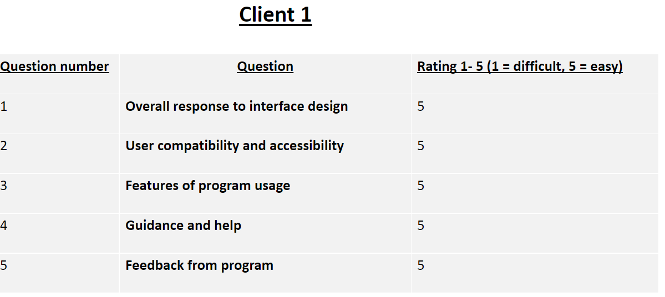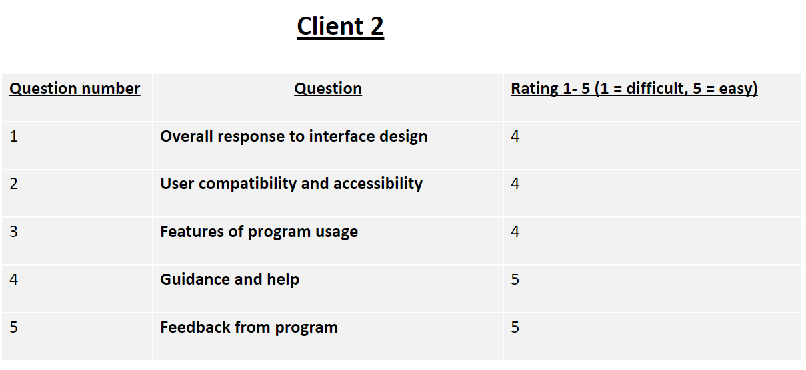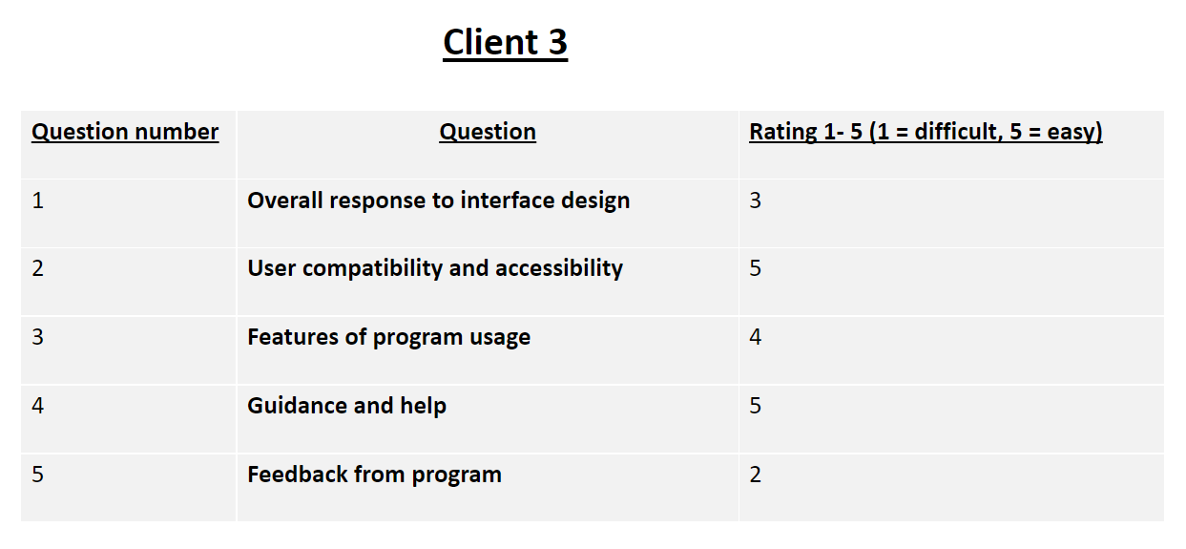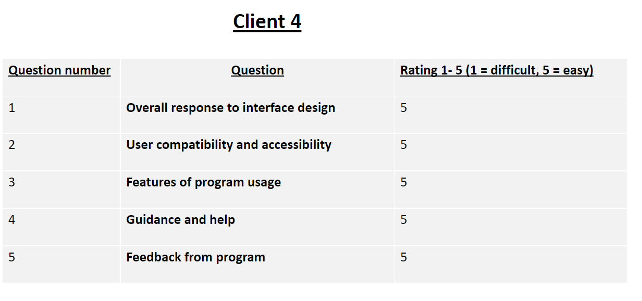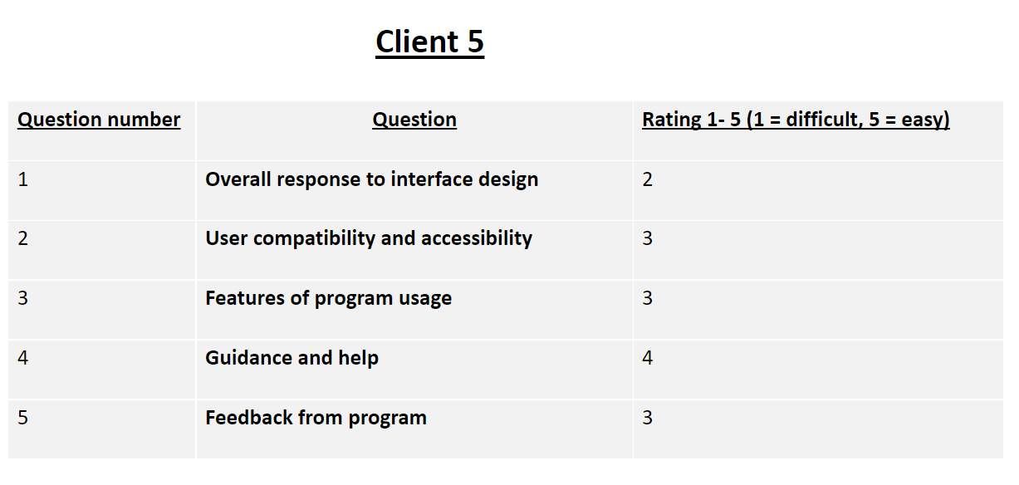

## **Discussion on results from questionnaire**

Overall, of the 5 results we can see were mostly positive. By creating this, we can look at areas which did not score high and work on improving them. For example, someone said rated 2 on the feedback so we can render the feedback system and improve it. However, an additional 3 people rated the feedback system a 5 (extremely easy). This can mean it is only 1 person who is not satisfied but it is not a major problem. What we can take back from this is we can ask for improvement from that specific client and try implementing our feedback system to satisfy them. However, it would be best not to make major changes because in comparison to this 1 low review we also got 3 high reviews on these same areas of the program.

Areas which have overall positive feedback will not need any changes, but we can still ask the clients if they have made any improvements and see if we can adapt their options in a positive way.

## **Improvements made based on feedback**

Errors are one area that has seen significant improvement. An error message will prompt the user to try again and provide some inputs if the user enters a search that does not correspond with any of the menu options.

Page numbers now appear at the bottom of each page to show users how far into the program they are. Two interviewers suggested this because it would make it easier to determine how long and how many additional steps are required.

The feedback feature, which received a low overall score but received a high overall score, is another area that has been improved. We asked the customer if they had any suggestions, and we also asked the high-rated customers if they agreed. We carried out this implementation after the final vote was 4/5. There is now an audio guided MP4 video explaining the feedback in the program. For instance, if a user clicks Next without selecting a choice, a video and tutorial on how to fix the error will be displayed.

## **Review of development process**

My designs are appropriate for the audience and their intended use. Because it fulfils all the anticipated requirements that were intended, I can guarantee this. For instance: home page, subpages, return and next buttons, zooming in and out, magnification, and numerous other features

My design is amazingly straightforward and user-friendly. In case you get lost, there are also mp4 videos to help you along. By conducting a questionnaire and adjusting, I have attempted to make the design as user-friendly as possible for all clients. For instance, someone mentioned that they were unsure of how to use the device, so I made it easier to use by including a video tutorial, a keyboard, and text-to-speech technology. The design of my model runs on software, making it portable in a sense. Because of this advantage, the system can be installed and used by multiple devices. Creating an app that can be installed on another device is all that is required to accomplish this.

Except for smartphones, my design works on all devices. It will be difficult to use on a phone due to its size, so I have done this.

My accessibility is ethical and legal. To do this I made sure my design follows these questions:

What are the issues facing the users I am designing for?

Is there a social or environmental cost to my approach?

How do I keep my product from discriminating against its users?

My system does not use any trademark or copyright data and pictures. Making it very ethical and legal.

Getting reviews from the public was a great idea as it gave me knowledge of where my design needed improvements. I made a few necessary changes which I have listed above.

### **Evaluate your skills (D3)**

Throughout this project I have been managing time well, making sure each area is up to date with completion. Making sure that feedback from questionnaires are reviews and changes are made accordingly. Following my test plan helped make sure I wasn’t falling behind, which I created and proved with a screenshot near the top of this document.

I have been very independent and professional in this task. One way I did this was by getting some help from internet and book sources, rather than asking others to help me out. For example, I read an article online which demonstrated how to create figma designs. This was my first time using figma to make a design, so I had no knowledge of this area. (Learn Design: Figma Design Basics | Figma).

While implementing my design, I would agree I have shown appropriate leadership. Firstly, I made sure the task didn’t run overdue with the support of an excel version Gannt chart to help myself track keep track with the time. I have also showed appropriate leadership skills in this task such as the following:

* Good listening
* Good communication
* Trying my best
* Being accountable
* Being exemplary
* Being inclusive

I used feedback from my manager to make sure everything is of good quality. While my manager is in contact with our clients it is best for me to ask and allow the manager to check with their requirements.

Throughout the development of this task, I supported others Aswell as use the support I got from others. As shown above I sent out a questionnaire to 5 different people and got their honest response. Some liked the design, and some found it basic. By using their support, I feel more confident that my design is more improved now.

I have evaluated my designs according to the client requirements which I have also labelled near the top of this document. Before applying any of my decisions and recommendations to the implementation I carefully carried out a test to check if it matches with the requirements, if not then it won’t be necessary, but I can decide if it will improve my design.

**M2 NOT met - Justified the design decisions, explaining how they will meet client requirements D2 NOT met - Evaluated the design and optimised HCI solution against the client’s requirements. P6 NOT met - Reviewed the extent to which the HCI solution meets client requirements.**

my design which I created have included all of the following interactive features and techniques which were also required by the client.

* zoom in and out – increase/decrees interface size
* access facilities – large text / languages
* points of interest clearly identified for all - Fire escapes
* current location
* search function interactive keyboard
* audio feedback
* tasks to be performed
* input required – touchscreen and voice
* output required – graphics and audio feedback
* user needs including accessibility considerations, the purpose of the system and environmental.
* mood boards for your layout ideas
* design solution:

client requirements

hardware and software requirements

detailed flowcharts

annotated storyboards

technical specification for the file formats required bandwidth limitations, target platform

technical designs-code

consideration of design rules.

My designs meet the following criteria which is required by the client. The way I did this was by checking against the clients' requirements listed in the assignment brief, after I had a good understanding of what was needed, I began creating my designs and rechecking against the criteria. I also got feedback from the client which helped me double check if there were any areas missed out. This is all explained above in this document near the customers feedback from the questionnaires.